Preparing Survey Data for Analysis

Reverse-coding Items as Needed

- Open the Practice Survey Data dataset and review it.

- For this dataset, 80 participants completed an online survey that included an adapted Self-Compassion Scale (Neff, 2003) using a seven-point Likert-type scale.

1 = strongly disagree
2 = disagree
3 = slightly disagree
4 = neutral
5 = slightly agree
6 = agree
7 = strongly agree

1 | When I fail at something important to me I become consumed by feelings of inadequacy.
2 | When I fail at something that’s important to me, I tend to feel alone in my failure
3 | I try to be understanding and patient towards those aspects of my personality I don’t like.
4 | When something painful happens I try to take a balanced view of the situation.
5 | When I’m feeling down, I tend to feel like most other people are probably happier than I am.
6 | When I’m feeling down I tend to obsess and fixate on everything that’s wrong.
7 | When I feel inadequate in some way, I try to remind myself that feelings of inadequacy are shared by most people.
8 | I try to see my failings as part of the human condition.
9 | When I’m going through a very hard time, I give myself the caring and tenderness I need.
10 | When something upsets me I try to keep my emotions in balance.
11 | I’m intolerant and impatient towards those aspects of my personality I don’t like.

- Participants also completed an adapted version of a well-known gratitude questionnaire (GQ-6; McCullough, 2002). Our adapted version is a five-question gratitude questionnaire. This was scored on the same seven-point Likert-type scale as the Self-Compassion Scale.

1 | I have so much in life to be thankful for.
2 | If I had to list everything that I felt grateful for, it would be a very long list.
3 | When I look at the world, I see so much to be grateful for.
4 | I am grateful to a wide variety of people.
5 | As I get older I find myself more able to appreciate the people, events, and situations that have been part of my life history.

- Each item was labeled automatically by the survey program in order. So the variables names go from SCS_1 to SCS_12 for the Self-Compassion scale. The variable names go from GQ_1 to GQ_5 for the gratitude questionnaire.

- Now we need to identify which, if any, items require reverse-coding for each of our scales. Remember that we want bigger numbers to always mean the same thing.
  - For example, if we look at item 11 of our self-compassion scale, “I’m intolerant and impatient towards those aspects of my personality I don’t like,” if you picked “strongly agree” you would have a “7” in the data but that’s the opposite of self-compassion! So this is an item we need to reverse code. Identify all the other variables that need reverse coding and list them below:

- In order to do the reverse coding, add a column alongside each of the variables in need of reverse-coding *hint, there are 5*. Label each new column with a variable name so that you know what it will represent (for example: SCS11_REVERSE).

- Insert a formula in the top empty cell (row 2) of each new column in order to end up with a reverse-coded version of the relevant column. The best way to do this is to type: = 8 - [click to highlight the score for that person that needs to be re-coded]. Then hit enter. This formula will ensure a 7 becomes a 1, a 6 becomes a 2, etc. Note you do not have to re-type this formula in each row: instead, simply click and hold the lower right corner of the cell and drag it down the column to the bottom row. Repeat this process for all columns that need to be reverse-coded. You may want to visually inspect the rows to ensure this was done correctly.
  - The formula you should use should subtract from one MORE than the amount of points on your Likert scale.
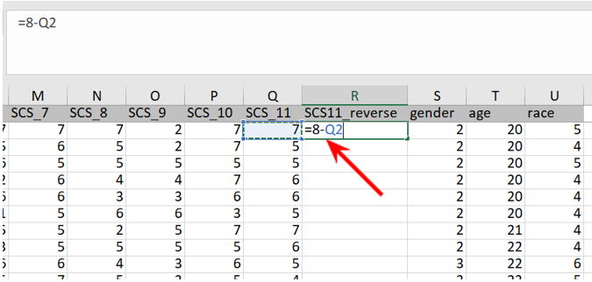

- Repeat this process for all items that require reverse-coding. Take your time and be careful. Attention to detail is important.

Making a scale average for data analysis

- Make an extra column at the end of each scale. Label each so you know it will represent the scale average. Click on the empty cell at the top of your new, empty “SelfCompassion” column and insert an AVERAGE formula, where the items to be averaged are statements are all your reverse-coded items.
  - MAKE SURE YOU DO NOT INCLUDE the non-reverse-coded original statements in your formula!!! The image below shows the start of the formula, but not the complete thing. Then you can do the same click-on-the-lower-right-corner-and-drag-down technique to fill out the formula for the rest of the participants in the column.
  - Do this for both Self-Compassion and for Gratitude.

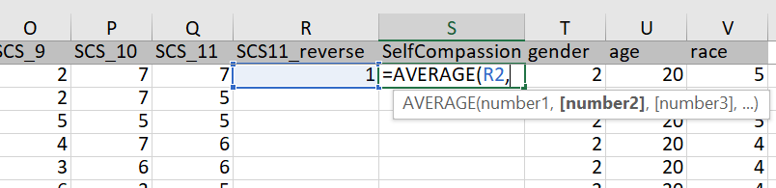

- SAVE THIS FILE in an Excel (.xlsx ) format. This will keep your formulas intact. You may want to name it something that makes that clear (for example, Survey activity Formula file). This way, if you made a mistake, this file will help you identify the mistake or correct it.

- Save this file in a .CSV format and make sure you have it stored safely! This is the version you can use in JASP. This file will erase all your formulas and only keep the values available.

Descriptive Analyses of Scales/Questionnaires

Calculating the Reliability of your Questionnaire

- First, we are going to determine the internal consistency of our scale. To do this, we will use Cronbach’s alpha (just like we did for our observational lab).

- Start with the Gratitude measure. Drag over the five gratitude items and run the reliability analysis. α = _____________
  - Using the metrics from the observational lab, describe how reliable our gratitude scale is __________________

- Now, we have to the same for the Self-Compassion scale. But remember we have reverse-coded items. So you need to include your reverse-coded items (but not the original non-reversed versions). You also need to include the regular items that did not need reverse coding. In other words, each item needs to be included ONCE, which means you will have 11 items total included in your reliability analysis. α = _____________
  - Using the metrics from the observational lab, describe how reliable our self-compassion scale is __________________

Getting the Mean and SD of your Questionnaire

- Finally, we want to know the typical descriptive information about our questionnaires/scales/measures. To do this, we run descriptives on the variables we created that represent each participant’s average score on the scale.

- Provide the descriptives for the Gratitude Questionnaire:
M = ______________, SD = _______________

- Provide the descriptives for the Self-Compassion Scale:
M = ______________, SD = _______________

- Challenge question: Try to interpret the mean using the scale anchors and labels.

Writing up questionnaire information in a lab report.

- Questionnaires need to be sufficiently described in the Method section but we usually do not report every single item (this would be terrible for readability). Instead, we usually provide the following information:
  - Number of items in the scale
  - Number of scale points (for example, “on five-point Likert-type scales”)
  - Provide the anchor labels (for example, “on five-point Likert-types from “Strongly Disagree” (1) to “Strongly Agree” (5)” that make it clear which number goes with which anchor.
  - Provide one or two example items:
    - For example, Example items include, “I am happy,” and “I feel hopeless” (reverse-scored).
  - Explain how this measure was prepared for data analysis.
    - For example, “After reverse-scoring as necessary, items were averaged together to create an overall happiness score.”
    - Some scales do not make you average and instead have you sum up the items or other sorts of things. This is why it is important to indicate that you averaged them.
  - Provide descriptive information on the scale, especially regarding its reliability. If the reliability is poor, then you have no justification for averaging the items together.
    - For example, “After reverse-scoring as necessary, items were averaged together to create an overall happiness score (α = .89, M = 2.76, SD = .43)”
    - If you do not provide this information in the Method section, then you would need to provide it either in the Results section (this would come before any inferential analyses) OR in an APA-formatted table which you must refer readers to within the text. See Table 1 for an example descriptive table for questionnaires.

Table 1. Example APA Table with Made-Up Questionnaire Information
Measures | Cronbach’s  Alpha | Mean | Standard Deviation
Happiness | .89 | 2.76 | .43
Perceived Luck | .76 | 5.9 | 1.25
Imagination | .81 | 6.4 | 1.44
Note: Happiness items were scored on five-point Likert-type scales. Perceived luck and imagination items were scored on seven-point Likert-type scales.

Now, try to write up this data!

Remember participants completed an online survey. Participants were recruited through advertisements that appeared on Facebook and Instagram and received $1.00 through PayPal for completing the survey.

But first, here’s more information about your data to help you out.
Gender
1=Female
2=Male
3=Nonbinary

Race
1=Black or African American
2=Indigenous
3=Asian
4=White
5=Latino/Hispanic
6=Multiracial or Other

Now, try to follow these same steps for our Survey Study.

Recall that in our last lab we considered a variety of constructs that psychologists have used to study individual differences in people’s personality and attitudes. We ended up selecting the following constructs and generating the four hypotheses below:
- Neuroticism: A personality trait characterized by “the tendency to experience unpleasant emotions easily, such as anger, anxiety, depression, and vulnerability.” [Wikipedia]. Higher scores on this measure correspond to higher levels of neuroticism (John & Srivastava, 1999).

- Satisfaction with Life Scale (SWLS): A measure of global cognitive judgments of one’s life satisfaction (Diener, Emmons, Larsen, & Griffin, 1985)

- General Belongingness Scale (GBS): A 12-item measure that assesses a person’s sense of achieve belonging (Malone, Pillow, & Osman, 2012)

- Perceived Efficacy in Statistics: 3 questions measuring an individual’s perceived confidence and competence in dealing with statistics (Frederickson et al., 2005).

H₁: Neuroticism is negatively correlated with General Belongingess
H₂: General Belongingness is positively correlated with Satisfaction with Life

You can find all of the data we collected in the file called RM1_CorrelationData.csv” on Moodle.

Before we test our hypotheses, we need to “code” each of our measures into a single value for each participant. Remember, each measure consisted of multiple questions or statements, so in order to compute our correlations we need to find the mean or sum score on responses to the statements for each participant for each measure. I already went ahead and coded up GBS, so all you have to do is code up Neuroticism. But, because of our survey design, this requires a few extra steps:

- Coding Neuroticism: Remember that the higher you score (i.e. the more strongly you “agree”) on these measures is supposed to mean that you scored higher on the personality trait in question. However, some of the statements for the Neuroticism measure (colored in red in the image below) are actually supportive of the low end of the measure. So, if you strongly agree with those you would actually score low on the trait. This is standard practice in survey design to make sure participants aren’t just agreeing or disagreeing with every statement without reading them. As a consequence, however, these red statements have to be “reverse-coded” in our data file. That means if you “strongly agree” with those statements (which results in a score of 5), we need to recode that as a “1”. If you “agree a little” (score of 4), we need to recode that as a 2. Neither agree nor disagree can stay the same at 3. “Disagree a little” needs to be recoded from 2 to 4, and “Disagree strongly” needs to be recoded from 1 to 5.

- In order to do the reverse coding, open up the survey data file. Now, add a column next to each of the 3 statements in need of reverse-coding (Neuroticism2, Neuroticism5, and Neuroticism7). Label each new column so that you know what it will represent (for example: Neu2_REVERSE).

- Insert a formula in the top empty cell (row 2) of each new column in order to end up with a reverse-coded version of the relevant column. The best way to do this is to type: = 6 - [click to highlight the score for that person that needs to be re-coded]. Then hit enter. This formula will ensure a 5 becomes a 1, a 4 becomes a 2, etc. Note you do not have to re-type this formula in each row: instead, simply click and hold the lower right corner of the cell and drag it down the column to the bottom row. Repeat this process for all 5 columns that need to be reverse-coded. You may want to visually inspect the rows to ensure this was done correctly

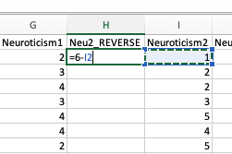

Once you have reverse-coded the 3 relevant statements, you can compute the actual Openness to Experience scores for each participant.
- Click on the empty cell at the top of the empty “Neuroticism” column and insert an AVERAGE formula, where the items to be averaged are statements are 1, 2reversecoded, 3, 4, 5reversecoded, 6, 7reversecoded, 8. MAKE SURE YOU DO NOT INCLUDE the non-reverse-coded statements 2, 5, and 7 in your formula!!! The image below shows the start of the formula, but not the complete thing. Then you can do the same click-on-the-lower-right-corner-and-drag-down technique to fill out the formula for the rest of the participants in the column.

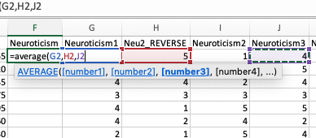

- SAVE THIS FILE in a .CSV format and make sure you have it stored safely!
Now that your survey data is all coded up, you are ready to run some correlational analyses in order to test our initial hypotheses.
- Load the updated data file into JASP. Make sure all of the measures are coded as continuous (except participant and gender, which should be categorical).

- Calculate the alpha reliability for the Satisfaction with Life scale by including the five SWLS variables.

- Calculate the alpha reliability for Neuroticism by including each of the neuroticism items. Note here that for items that you reverse-coded, you include the reverse-coded version of the item and not its original.

- Calculate the alpha reliability for the General Belongingness scale by including each of the belongingness items (again including the reverse-coded, rather than original items where appropriate).

- Calculate the descriptives for each of these measures.

- Click on the “Regression” tab and then click “Correlation Matrix”.
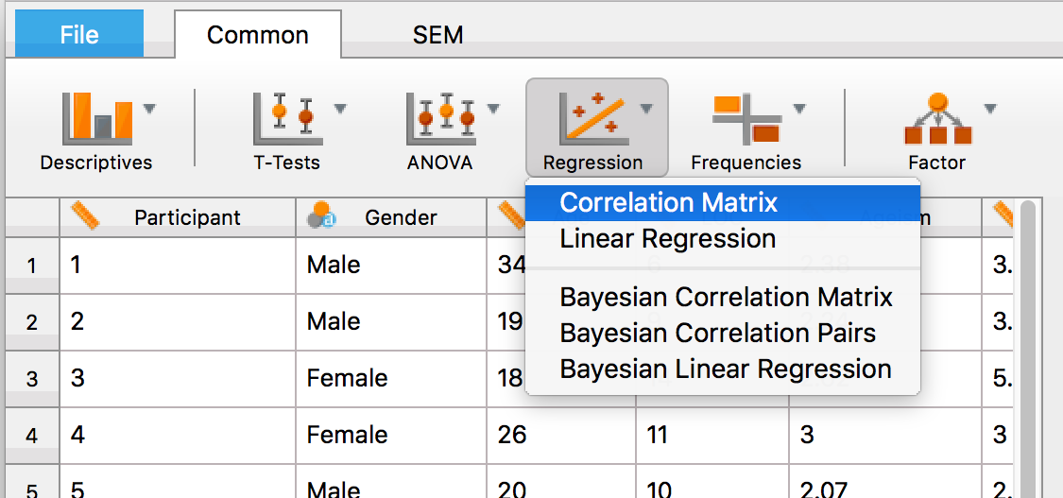

- Now, to test our first hypothesis (H₁), move the “SatLife” and “Belogingness” variables over to the box on the right. Make sure you click on “flag significant correlations” as well “correlation matrix” (under the plots section) in order to get a scatterplot (with a “regression line”) of your data. Note as well that under “Hypothesis” we are going to stick with the more conservative, two-tailed, hypothesis that the measures are “correlated” in general, without specifying in which direction (which would be a one-tailed test; we will discuss this in more detail next week).

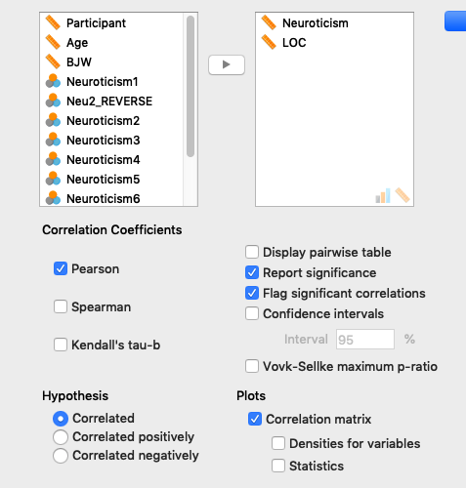

- Now on the right you should see a table (and a graph) with the correlation value (r) and whether or not the correlation was statistically significant. We will discuss as a group how to write this up in APA format for your lab report.

- Repeat this process for our second hypothesis. Note: in order to get additional tables/graphs for each analysis, rather than changing the values on the ones you already generated, you have to go back up and click on the “Regression” tab to insert a new correlation analysis.

- Were the hypotheses supported or not? Turn to your neighbors to discuss your findings to make sure your results are consistent. Save the JASP file and store it on your flashdrive (or email it to yourself) so you can reference it when writing up your lab report.

- Finally, calculate your participant descriptives for your Participants section.

NOTES FOR WRITING A PRACTICE REPORT
- When it comes to describing the 3 measurement scales we examined, you do not need to include every single statement participants responded to in your methods section. Instead, provide:

  - an overview of the scale and what it measures
  - how many items participants responded to
  - how they responded (scale information)
  - one or two examples of the statements participants responded to.
  - Explanation of how the measure was scored
  - Relevant descriptive information

So, imagine we had used an “extraversion” scale. You could write something like:

“The first scale participants responded to was a measure of extraversion, a personality trait that describes how outgoing and socially engaged people are (John & Srivastava, 1999). The scale consisted of eight statements (e.g., “I see myself as being outgoing and enthusiastic”), and participants had to rate their level of agreement with each statement on a 5-point Likert scale ranging from 1 (strongly disagree) to 5 (strongly agree).” After reverse-scoring necessary items, scores were averaged together to create an extraversion score in which higher numbers indicated greater extraversion (α = .78, M = 3.92, SD = 0.64)

- You have some discretion as the author to instead include information about the scoring and descriptive statistics of your measures in the Results section. However, it’s easiest for you to just create a Measures section and input it there until you are more comfortable with writing research reports.

- You should also CITE in the methods section the articles where we got the measures we used in the survey if they are not made by you/us for the purpose of our study. When citing in the text, APA rules are to do the following within parenthesis:
    - Use this format (Last Name, YEAR) for one author
    - For two authors: (LastName & LastName, YEAR)
    - For three or more authors only the first author gets named: (Last Name et al., YEAR)
      - Note: “et al” is Latin for “and others” so we’re naming the first author and then saying “and others”
    - Example: (John & Srivastava, 1999) keep in mind that “John” is actually the first author’s last name

